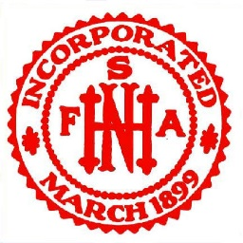
New Hampshire State Firemen’s Association November 16, 2023
124th Annual meeting

- Meeting call to order with pledge of allegiance to the flag of our country and a moment of
silence for our departed members and injured members.

- Sargent at Arms announcement of number of members present to vote.

- Secretary’s report - John Lacasse

- The following bills to be paid –

- Treasurer’s Report – Derek Danis-

- Provident report – Thomas Green –

- Department Update Reports:
- Belknap – Ron Howe –
- Carroll – Vacant –
- Cheshire – -
- Coos –– Derek Palmieri -
- Grafton – Dan Boynton -
- Hillsboro – Brandon Merron -
- Merrimack – Paul St. Germain -
- Rockingham – Cliff Cray –
- Strafford – Larry Benoit –
- Sullivan – Charles Barlay –
- 2st Vice – Dan Boynton –
- 1st Vice – Chris Wyman –
- President – Thomas Green
- Public Relations – Kendall Hughes

- Membership Director- Christa Caron

- New Hampshire Fire Standards and Training Commission – Frank Fraitzl

- Recruitment and Retention Committee Tom Blanchette

- Committee of Merit - Paul St. Germain

- Memorial Committee – Earl Lincoln

- Legislative Report –

- Committee reports:
  - Conference/annual meeting committee – Larry Benoit (125th anniversary)
  - Fundraising Committee
    - Challenge Coins and Decals
    - Phone solicitation – Tom and Derek

- Nomination of Officers:
- President - 3-year Term
- Second Vice President – 2-year Term
- Secretary - 3-year Term
- Treasurer - 3-year Term
- Grafton County Representative - 3-year Term
- Hillsborough County Representative - 3-year Term
- Merrimack County Representative - 3-year Term
- Sargent at Arms – 1- year term

- Old Business –

- New Business –

- For the good of the order -

- Next meeting of the Association and Executive Board –

- Call to adjourn

